Assignment 6.1

1. I have created database by using create command

hive> create database custom;

1. Now checking database present as shown below

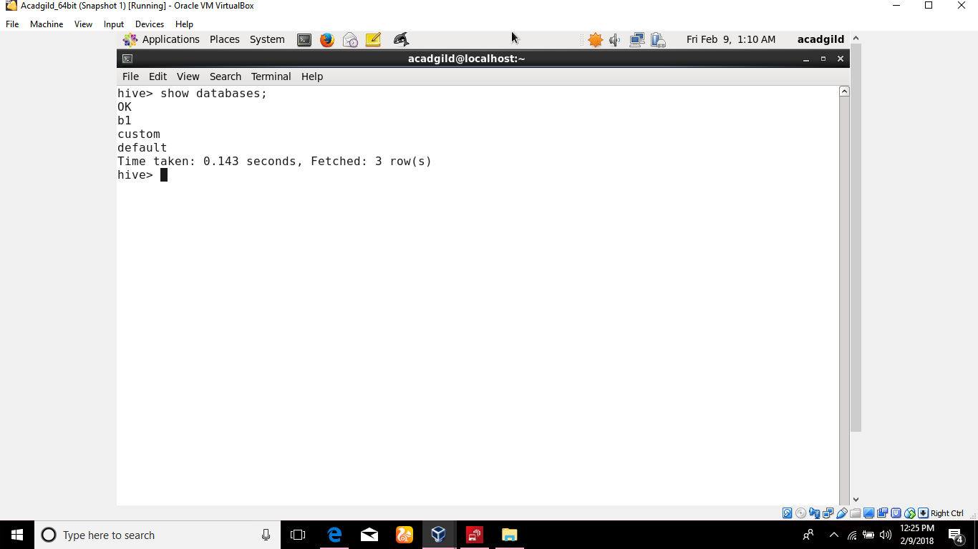

1. Now to create table name temperature_data inside custom database , we have use the database as shown in below snapshot

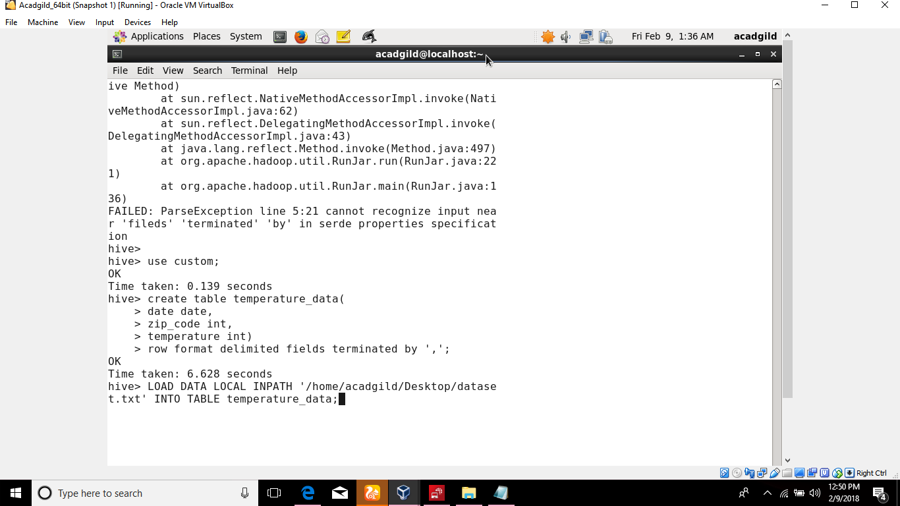

1. Now checking if any tables present in database , and creating table with the name temperature_data as shown below.

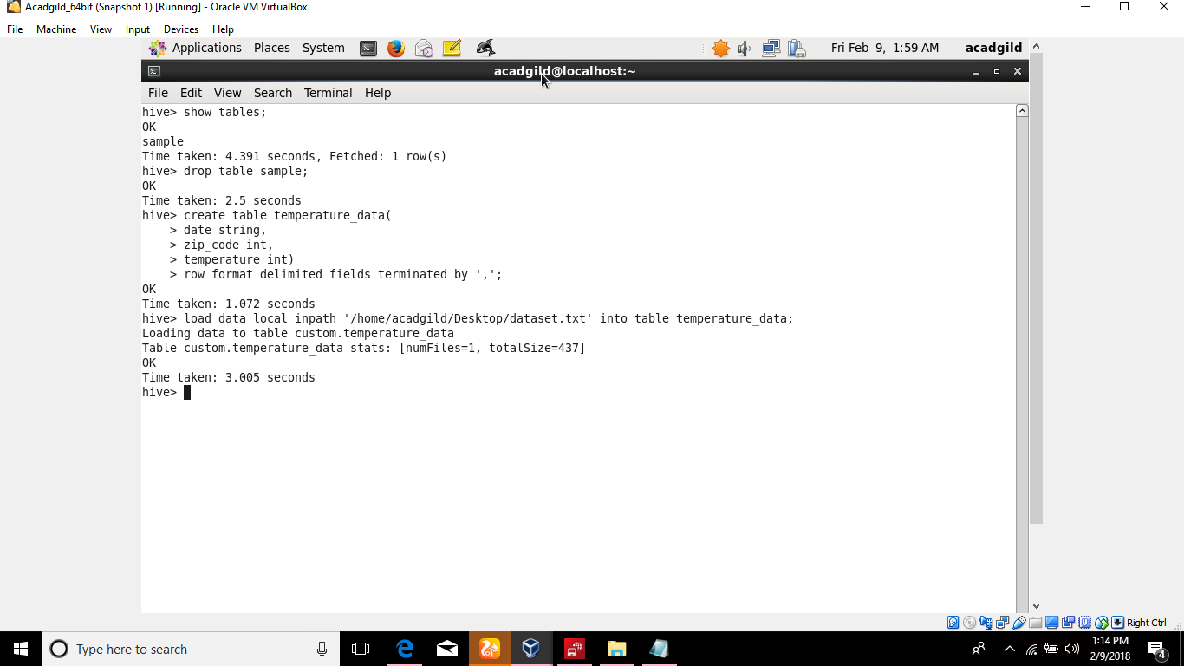

1. After creating table , Im loading dataset.txt which is already there in Desktop by using load command as shown below. And finally viewing data using select clause.

